**SPRINT – 1**

**WORKING WITH THE DATASET (UNDERSTANDING THE DATASET)**

|  |  |
| --- | --- |
| Date | 20-10-2022 |
| Team ID | PNT2022TMID39865 |
| Project Name | Estimate The Crop Yield Using Data Analytics |

“Estimate The Crop Yield Using Data Analytics” project is based on understanding the crop production of India. Download the dataset from the below link. It has 2,46,092 data points (rows) and 6 features (columns) describing each crop production related details.

**Dataset Link** : [Dataset](https://www.kaggle.com/abhinand05/crop-production-in-india)

Let’s understand the data we’re working with and give a brief overview of what each feature represents or should represent

1. State Name - All the Indian State names.
2. District Name - Different District names.
3. Crop Year- contains the crop years.
4. Season - Different seasons for crop production.
5. Area - Total number of areas covered.
6. Production - production of crops.

**UNDERSTAND THE DATASET:**

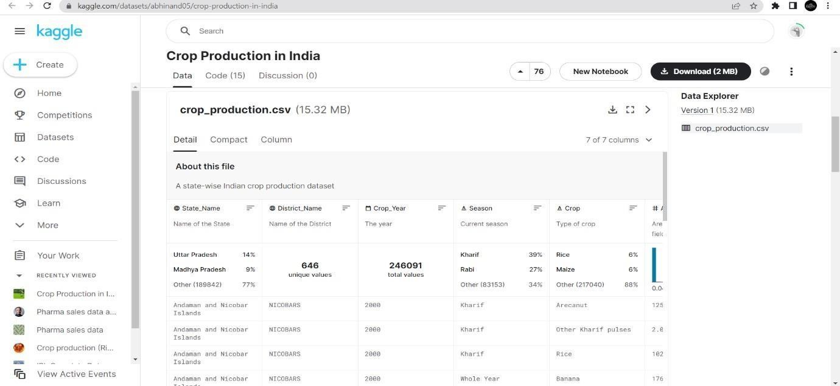

* + Download the dataset from the given dataset link.
  + Data Given in csv file is understood.
  + The data format is as shown in the below image:

